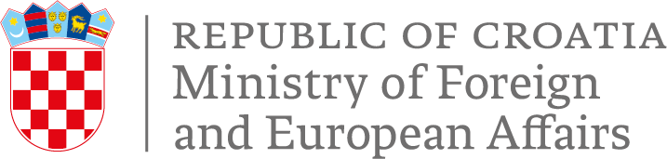
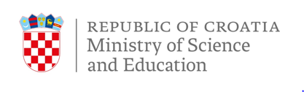

SCHOLARSHIPS
FOR YOUNG CHRISTIANS FROM DEVELOPING COUNTRIES

The Ministry of Science and Education of the Republic of Croatia and the Ministry of Foreign and European Affairs are awarding the Croatian Government Scholarships for undergraduate and graduate university study to young Christians from developing countries, for the 2023/2024 academic year.
The national framework for development cooperation of the Republic of Croatia pays particular attention to promotion of the interdependence of human rights, peace, security and sustainable development, while promotion of the right to education, based on principle of equality, regardless of religious, national or other affiliation, is one the key priorities of Croatian international development policy.
Religious minorities, including Christians, are one of the vulnerable groups in the world, particularly in developing countries. The Government of the Republic of Croatia has recognized this negative trend on a global scale, and is committed to respecting and protecting the rights of religious groups.
The scholarship is awarded to the citizens of the developing countries from the Middle East, Asia and Africa, from 18 up to 23 years of age.
The awarded scholarships cover expenses of the one academic year of preparatory Croatian language course, undergraduate (BA) or graduate (MA) program, full board and lodging, monthly allowance and travel costs.
Information about the Croatian higher education institutions and programs can be obtained on http://www.studyincroatia.hr/ and http://mzos.hr/dbApp/pregled.aspx?appName=ustanove_Z.
After completing their studies, students are required to return to their home countries. They are expected to contribute to development of their communities, local capacity building and strengthening resilience at the local level.
Selection process will be performed through local church communities and Dioceses by the end of June 2023.

